Number
A number is a mathematical object used to count, measure, and also label.
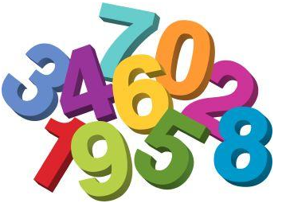

Comparing Numbers
1. Compare 4978 and 5643…….
5643 is greater as the digit at the thousands place in 5643 is greater than that in 4978.
2. Compare 9364,8695,8402 and 7924
9364 is the greatest as it has the greatest digit at the thousands place in all the numbers.
Whereas 7924 is the smallest as it has the smallest digit at the thousands place in all the numbers.
3. Special case
Compare 56321 and 56843
Here, we will start by checking the thousands place.As the digit 5 at ten thousand place is same so we will move forward and see the thousands place. The digit 6 is also same so we will still move on further to check the hundreds place.
The digit at the hundreds place in 56843 is greater than that in 56321
Thus 56843 is greater than 56321

Proper Order
- If we arrange the numbers from the smallest to the greatest then it is said to be an Ascending order.
- If we arrange the numbers from the greatest to the smallest then it is said to be Descending order.
Example
Arrange the following heights in ascending and descending order.
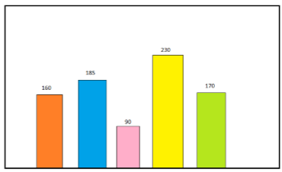
Ascending order – 90 < 160 < 170 < 185 < 230
Descending order – 230 >185 >170 > 160 > 90

Number Formations
Form the largest and the smallest possible numbers using 3,8,1,5 without repetition
Largest number will be formed by arranging the given numbers in descending order – 8531
The smallest number will be formed by arranging the given numbers in ascending order – 1358
Introducing 10,000
99 is the greatest 2-digit number.
999 is the greatest 3-digit number
9999 is the greatest 4-digit number
Observation
- If we add 1 to the greatest single digit number then we get the smallest 2-digit number
(9 + 1 = 10)
- If we add 1 to the greatest 2- digit number then we get the smallest 3-digit number
(99 + 1 = 100)
- If we add 1 to the greatest 3- digit number then we get the smallest 4-digit number
(999 + 1 = 1000)
Moving forward, all the above situations are same as adding 1 to the greatest 4-digit number is the same as the smallest 5-digit number. (9999 + 1 = 10,000), and it is known as ten thousand.

Place Value
It refers to the positional notation which defines a digits position.
Example
6931
Here, 1 is at one's place, 3 is at tens place, 9 is at hundreds place and 6 is at thousands place

Expanded form
It refers to expand the number to see the value of each digit.
Example
6821 = 6000 + 800 + 20 + 1
= 6 × 1000 + 8 × 100 + 2 × 10 + 1×1
Introducing 1,00,000
As above pattern if we add 1 to the greatest 5-digit number then we will get the smallest 6-digit number
(99,999 + 1 = 1,00,000)
This number is called one lakh.

